|  |
| --- |
| Pre-Installation Checklist for windows server  August 2015, robert Barcikowski |

This checklist can be used to validate the Windows Server infrastructure built by IBM

## Pre-Installation Checklist Part 1. Excel spreadsheet

* + Open the file in Excel: [**Pre-Installation Checklist.xlsm**](https://teams.cts.nab.com.au/workspaces/IODKnowledgeBase/Shared%20Documents/Pre-Installation%20Checklist.xlsm?Web=1)
  + Right click on the **aupr2ap198nabwi** tab, and click on Move or Copy…
  + Tick the Box: **Create a Copy**
  + Select **(move to end),** then click on **OK**
  + Right click on the **aupr2ap198nabwi (2)** tab, and click on **Rename**
  + Populate the **Expected Values** (column B) from the information found in the IBM detailed solution/design, for example:  
      
    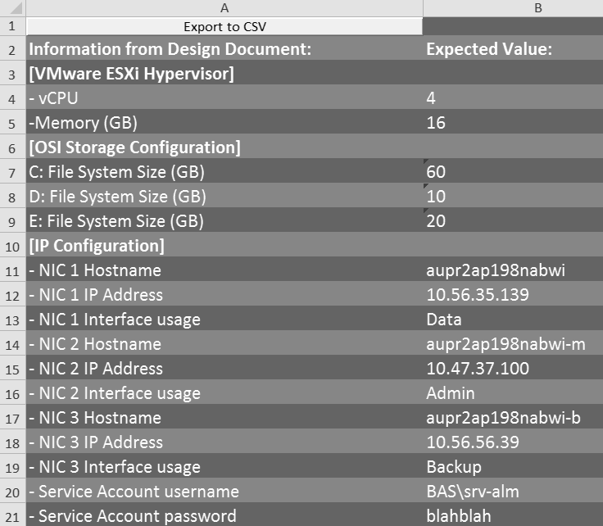
  + Click on the **Export to CSV** button, located in position A1 of the worksheet.
  + This will export the current worksheet to a file on your desktop, using the worksheet name as the filename (e.g. **aupr2ap198nabwi.csv**)
  + Proceed to Part 2…

## Pre-Installation Checklist Part 2. VBScript

* + Copy the CSV file (e.g. **aupr2ap198nabwi.csv**) and VBScript ([**pre-install-checks.vbs**](https://teams.cts.nab.com.au/workspaces/IODKnowledgeBase/Shared%20Documents/pre-install-checks.zip)) to a Temp folder on the server you wish to test (e.g. **E:\Temp**)
  + RDP to the server you wish to test
  + Create a shortcut to cmd.exe, then right click on the shortcut and choose **Run as administrator ,** and use your own Admin credentials
  + Change to the folder where the VBScript and CSV file are located, e.g. E:\Temp
  + Type the following command: **cscript pre-install-checks.vbs aupr2ap198nabwi**
  + Where **aupr2ap198nabwi** is the server you are logged in to, and the name of the CSV file
  + The script will now execute, and display info and/or error messages to the console, as shown below:  
      
    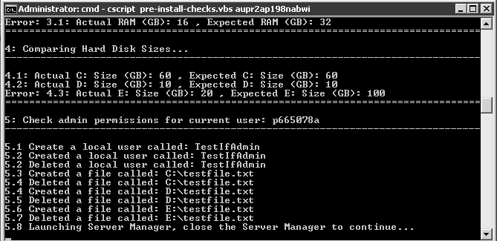
  + The **Server Manager** will launch to test your admin and/or the service account has admin rights, as shown below:  
      
    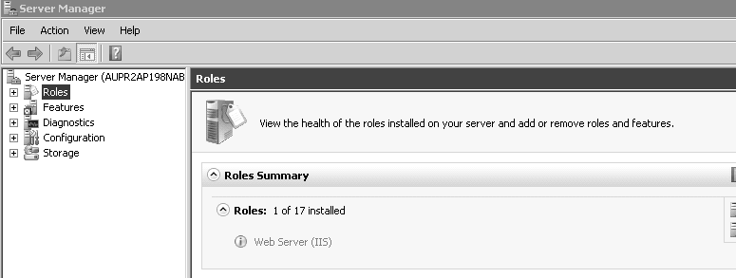
  + Close the **Server Manager** application, and the script will continue
  + Once the script has finished, open the log file **pre-install-checks.html** , which will show all passes as GOOD, and any failures as ERROR:

